# DOE 2 CTIA Array Chip Evaluation Manual

The purpose of this manual is to help users configure the circuit boards, computers, and hardware for characterizing components on the DOE 2 CTIA array low gain and high gain chips. The components that will be discussed are:

Simplified Schematic

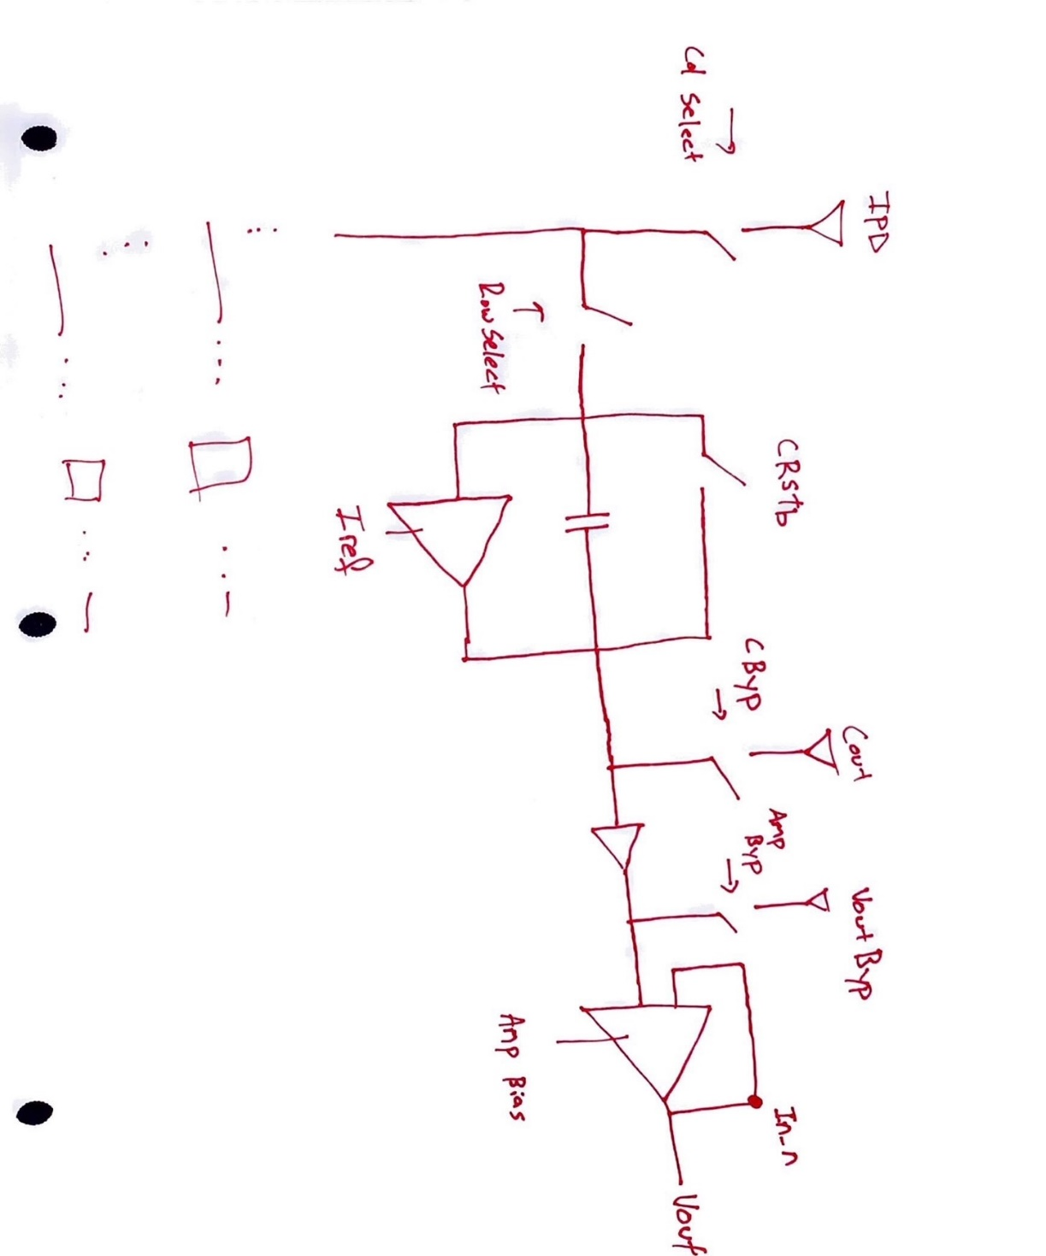

* CTIA Array
  + Reset Capacitor
* Common Drain Amplifier
* Operational Amplifier
  + Unity Gain Configuration

## Setting Up a New Computer

* Download and install visual studio code.
* Download and install miniconda3 in **C:\Users\**YOUR_USER_NAME.
  + Failing to do so makes your life harder.
* Download and install Git Bash.
* Go to <https://github.com/pewpeww39/RTSeval/blob/main/testequ.yml>.
* Create a new file in C:\Users\YOUR_USER_NAME\skywater.yml using skywater.yml.
  + Change line 1 to **name: skywater**.
  + Change last line to prefix: **C:\Users\**YOUR_USER_NAME**\miniconda3\envs\skywater.**
* Open anaconda prompt.
  + Type:
    - conda env create -f skywater.yml.
    - conda activate skywater.
* Open Git Bash.
  + Type:
    - cd ~/miniconda/envs/skywater
    - git clone https://github.com/pewpeww39/RTSeval.git
* Open Visual Studio Code.
  + load skywater environment into file explorer
  + python code is in RTSeval > python folder
  + select skywater interpreter if not done for you

## Pins On the Board

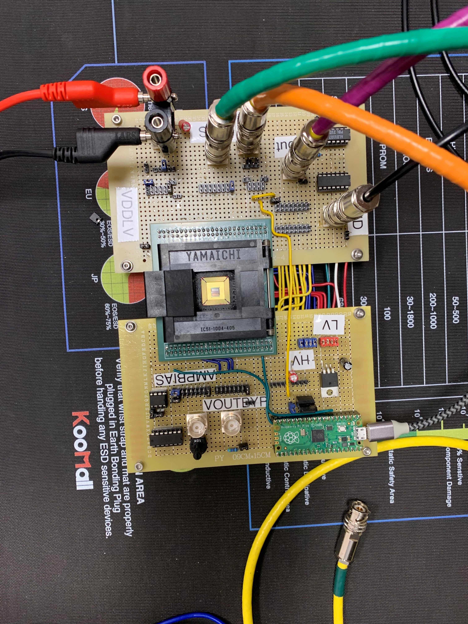

IPD Input – 0pA:100pA

IPD Jumper – Connects IPD Input to IPD pin

IREF Input – 0nA:100uA

COUT Output (0:7) – Jumpers start at zero.

IREF Jumpers – Connects IREF input to IREF pin.

+5.333 V Input – Connects power supply to board.

Ground – Connects SMUs to Ground

OUTPUTS (Below Inputs):

Data V out,

Clock out,

QP Out,

Data H out

INPUTS:

Clk,

Data vertical,

Data horizontal,

Gnd

Pins for shift register analysis.



CRSTBin – Connects CTIA Reset pin to Pi Pico

VoutBypass Jumpers and Input – Jumpers go from 0:7 starting at top

AmpBias Input and Jumper – Onboard jumper is covered

CBYPASSin – Connected to Ground

## Configurations

This section details what connections to make for testing specific components on the DOE 2 CTIA array low gain and high gain chips. From here on, the raspberry pi pico determines the board orientation, being at the top.

### Unity Gain Operational Amplifiers

Smub -> voutbypass

* Select the bank of the op amp by placing a jumper on the voutbypass 2x8 pin header connector.
* 0 starts at the top.

Smua -> vout (labeled on board)

* 2 Jumpers go on the two 2x8 pin header connectors. Their position vary depending on which op amp that is being characterized, but they will always be on the same number.
* Op amp zero starts at the top, so for unity gain one jumper would be placed on the left column and one on the right column at the top of the 2x8 pin header connectors.

GND -> SMU Lo

The on-board current source can be selected by placing a jumper on the pin header to the bottom right of the amp bias 2x8 pin header connector shown below.

To use an external -0.5 mA current source, remove the jumper and connect the external source to the amp bias BNC jack.

### CTIA Array Current Source/RTS Characterization



IPD Input -> SMUC – 0pA:100pA

IPD Jumper – Connects IPD Input to IPD pin

IREF Input -> SMUB – 0nA:100uA

COUT Output (0:7) -> SMUA

– Jumpers start at zero.

IREF Jumpers – Connects IREF input to IREF pin.

+5.333 V Input – Connects power supply to board.

Ground – Connects SMUs to Ground



CRSTBin – Connects CTIA Reset pin to Pi Pico

CBYPASSin – Connected to Ground

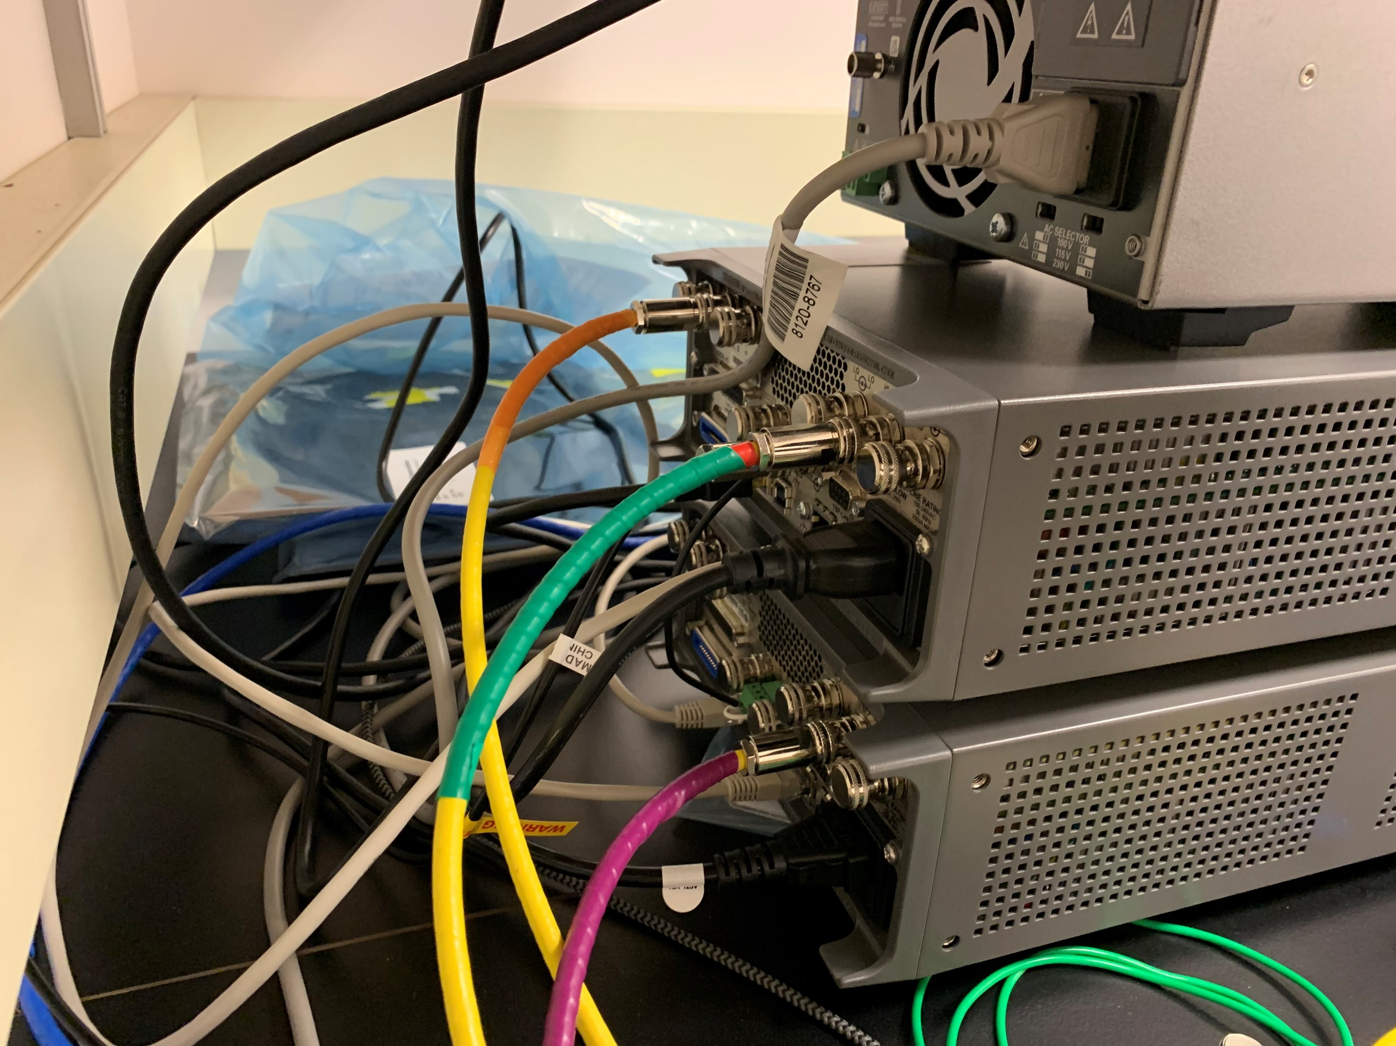

Iref SMU Output – Connects to IREF BNC jack

COUT SMU Input – Connects to COUT BNC jack

IPD SMU Output – Connects to IPD BNC Jack

Ground Connection – Connects SMUs together

Ground Connection – Connects board to SMUs ground

### Common Drain Amplifier Characterization

Smub -> cout

Smu -> voutbypass

GND -> SMU Lo

## DOE2 Python Functions

To characterize the components on the DOE 2 CTIA Array LG and HG chips with the Keithley 2636B Source meter units, open the python script DOE2_Functions.py script. After starting the script, the program will ask which test is being ran.  
Input:

1. Operational Amplifier Characterization
   1. Amplifier bank being tested. Answer 0:7
2. $I_{d} vs V_{sg}$ Characterization
   1. Current source bank being tested.
3. RTS Characterization
   1. CTIA array bank being tested.

The user change the parameters for $I_{d} vs V_{sg}$ Characterization and RTS Characterizations in the bankNum() function on lines 119-135 of the code.

For example:

Iref on line 134 is the current applied to the current reference to the chip. This value needs changed to increase or decrease the current applied to the current reference on the chip.